**DECISION SUPPORT SYSTEM INVOLVING TRADITIONAL FOOD RECIPES BASED ON MACHINE LEARNING**

***1K. P. Ragavi, 2B.G. Geetha***

*1 Department of CSE, K.S. Rangasamy college of technology, Tiruchengode, India*

*2Professor, Head of the Department, Department of CSE, K.S. Rangasamy college of technology, Tiruchengode, India*

**ABSTRACT**

Currently the consumption of food by the people has changed a lot. Because of several advancements due to enormous growth in technology, people has changed their food habits consumption. The upcoming generation will suffer a lot because of this problem. This situation will be avoided, if traditional food items come into existence. Traditional food items will give a better improvement in health when compared with consumption in tablets. Each disease is listed along with several details such as the tablets for each disease, its side effects and equivalent traditional food items for curing each and every disease. When traditional food items are properly consumed, side effects caused by the disease will be reduced to a considered amount. For these reasons traditional food items are consumed in-order to recover from the side effects caused by several diseases. Here the concept of machine learning is employed to make predictions based on the improvement percentage. Here it deals with providing details of traditional food items and its benefits. Each and every food item provides several medicinal values which lead to a healthy life. Then the disease details and the cause for the disease is provided. Then tablets to cure the disease is provided. As some tablets have several side effects, its corresponding traditional food items are provided, so the users can select the food items to cure the disease which affected them. Then machine learning is employed to predict the improvement factor when consuming traditional food item rather than taking tablets.

**I. INTRODUCTION**

Traditional food items are rich in nutrients. They act as fighting agent against many harmful diseases. The importance of each recipe is known to people based on the

curative factor in each traditional food item. The basis process involves introduction to the traditional food item and its importance. Several kinds of diseases that exist in the real world are then provided over here. Each disease is listed with its introduction, effects caused by the disease in the people health and some tablets to cure those diseases. As each disease is associated with some side effects, traditional food items are to be consumed in-order to get rid-off from those side effects caused by the diseases. **Arthur Samuel (1959)** speaks that machine learning is the main thing used here to make predictions based on the data which deals with the measurement of enhancement in the health. Machine learning is a practice of data examination that automates systematic model structure. Traditional Indian foods have been equipped for many centuries and groundwork differs through the country. Here it involves the following phases which includes providing overview of traditional food and its benefits, disease details, tablets details, alternative method to tablets.

**II. EXISTING SYSTEM**

The existing system deals with the several basic sites. It includes the basic information in separate sites which makes the task of people a difficult one. So they feel it a tedious process. Some sites have separate pages dealing with the details of each and every disease. A person has to refer about the disease in one site. Then the remedies for that in other site. It’s a time consuming task. As the existing system deals with the tablets to cure the disease, it leads to several side effects because of the several harmful chemical components in the tablets. Several side effects from drugs lead to severe infection which sometime may lead to death. Most similar side effects of any prescribed medicine are gastrointestinal issues, which includes nausea, constipation and diarrhea, because most drugs go through digestive system. Further, common side effects include drowsiness, pain and skin reaction. Common negligible side effects of prescribed drugs include diarrhea, dizziness, drowsiness, fatigue, heart issues (irregular heartbeats), hives, nausea and vomiting, rash, stomach upset. In-order to avoid from these situation, the site has been modified to ease the task of user.

**III. PROPOSED SYSTEM**

Traditional food items have numerous health benefits which has medicinal values in curing several detrimental diseases. When compared with tablets, traditional food items have gained a better improvement in recent days. For a particular disease, corresponding details will be provided along with the tablets for each disease. Each and every tablets have some severe side effects when not properly taken. For these reasons, traditional food items are consumed in order to recover from those diseases. Machine learning is a system of data examination that systematizes analytical model building. It is a branch of artificial intelligence based on the that machines should be able to learn and adjust through experience. Here the concept of machine learning is working to make estimation based on the improvement factor. Through this technique, several benefits have been obtained such as maintenance of blood sugar level, maintenance of weight loss, reduced cancer risk. less calories which plays a vital role in reducing the weight, increase in vitamin-A content, iron strength (better for muscles and blood), increase in calcium content which makes better for strong bones and teeth, helps in improving the problem of indigestion.

**IV.SYSTEM MODEL**

Traditional food of high shelf life rich in vital nutrients, that are panacea to the killer diseases, acquired from the fast culture of today are uploaded here as photos and videos. Each and every recipe uploaded is categorized on the basis of curative factor inherent in the ingredients. Some images of the traditional food items will be displayed in order to create attention from the user. Consumption of tablets and medicines lead to several diseases. First, user has to register themselves to the website.

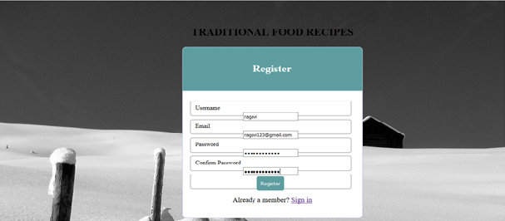

After getting registered to the website, user has to login into the website.

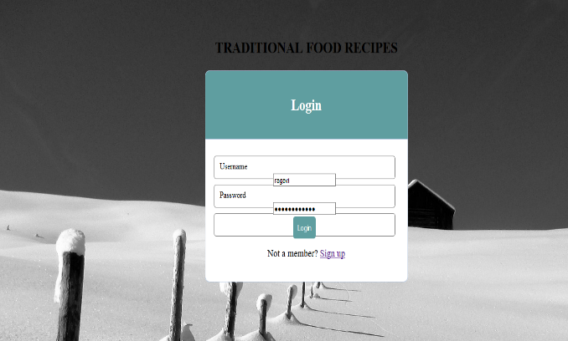

After getting logged in into the website, a person has to select the language that he or she is familiar. Then the list of diseases will be given. After that the details of the diseases will be provided. Then the cause for the diseases are provided. At last, tablets for the diseases are provided. Each and every disease have several tablets to cure them. Some tablets have severe side effects. So, side effects for each and every tablet has been provided. In order to get recover from those side effects, alternative method has been provided. An alternative method provided here is the consumption of traditional food item which plays a major role in curing the several side effects caused by the diseases. For those side effects, some of the traditional food items has been provided, along with its benefits and uses. Each traditional food item is provided along with its preparation images, videos and its tips. Each and every item is evaluated and predicted based on machine learning and Bayesian network.

**V. RESULTS AND DISCUSSION**

When compared to all food processing techniques, the concept discussed here is valuable and efficient because each and every processing deals with the particular field, here it deals with the processing of all food items which includes its benefits, advantages, etc., and the amount of curing the disease has been increased when compared to the remaining food processing techniques. The earlier concept deals with the tablets to cure the diseases. But in the proposed system, traditional food item replaced the place of tablets. So, when consuming traditional food items rather than tablets, disease rate has been decreased. Because in recent days the tablets are made with many harmful chemicals which leads to several kinds of diseases. So, this situation is avoided when consuming traditional food items.

**VI. CONCLUSION**

The project concludes that the food processing is done to reduce the count of several kinds of diseases and their side effects caused due to tablets. So that people comes to know about that the food items are available to cure the diseases rather than the medicine. Food processing can be done through many ways. Among that website creation is one which includes diseases, its tablets, effects and food items to cure the diseases through which the problems caused by several diseases is cured. So when consuming traditional food item, the count of people who are getting suffered from several kinds of diseases has been cured and reduced.

**VII. REFERENCES**

|  |  |
| --- | --- |
| [1] | Abdelhmid Salih (2014), “Novel Ensemble Decision Support and Health Care Monitoring System”, Journal of Network and Innovative Computing, ISSN 2160-2174 vol 2, pp. 041-051 |
| [2] | Cristina Yagüe-Ruiz, (2016), “Reduction of potassium content of green bean pods and chard by culinary processing -Tools for chronic kidney disease”, pp. 427-432 |
| [3] | Arash GHAREHBAGHI, Maria LINDÉN, (2017) “A Decision Support System for Cardiac Disease Diagnosis Based on Machine Learning Methods”, pp. 43-47 |
| [4] | Arash Gharehbaghi, Per Ask, (2016), “A Novel Model for Screening Aortic Stenosis Using Phonocardiogram”, pp. 48-51 |
| [5] | Armen kocharian, Azin Janani, (2016), “An Intelligent Phonocardiography for Automated Screening of Pediatric Heart Diseases”, pp. 1-16 |
| [6] | Chanda Dhumal, Shubham Subrot Panigrahi, (2015), “Traditional and ayurvedic foods of Indian origin”, pp. 97-109 |
| [7] | Daniel Pleissner, Francesca Demichelis, (2017), “Direct production of lactic acid based on simultaneous saccharification and fermentation of mixed restaurant food waste”, pp. 615-623 |
| [8] | Hooshyar,Preece, (2017), “Intensification of protein extraction from soybean processing materials using hydrodynamic cavitation”, pp. 47-55 |
| [9] | Jianbo Chen, Meijia Li, Lixue Chen, (2016) “Effects of processing method on the pharmacokinetics and tissue distribution of orally administered ginseng”, pp:1-8 |
| [10] | Komal Patel1, Ronak Chudasama, (2016) “Dairy Production Analysis and Prediction Tool using BIG DATA”, vol 02, issue 09, pp. 1-7 |
| [11] | Lim, Yang, (2015), “Big data analytics for empowering milk yield prediction in dairy supply chains”, pp. 1-11 |
| [12] | Marcel Wagner, Stefan Kaluschke, (2016), “Waste Reduction by Product-Quality based Scheduling in Food Processing”, pp. 584-589 |
| [13] | Raja Chakraborty, Saikat Sen, (2017), “Revival, modernization and integration of Indian traditional herbal medicine in clinical practice: Importance, challenges and future”, pp. 234-244 |
| [14] | Saikat Sen, Raja Chakraborty, (2015), “Toward the integration and advancement of herbal medicine: a focus on traditional Indian medicine”, pp. 33-44 |